Request Builder Solution
1- Aria.Configuration.Server:
Purpose:
This Project used to build desktop user interface to enable user from configure aria configuration server (request builder + some dll).
Contents:
1- Configure Server Form (CONFIGURESERVERFORM.CS):
This windows form used to contain some user control to handle all configurations.
- Each button in left side represent link to user control. 
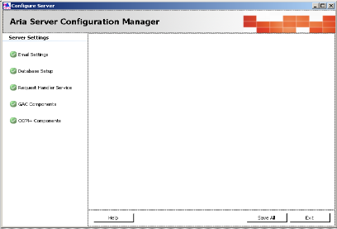

2- Email Settings Control (EMAILSETTINGSCONTROL.CS):
This is User control used to handle all setting related Email.
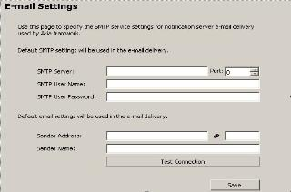

3- Database Setup Control (DATABASESETUPCONTROL.CS):
This is User control used to handle all setting related database (SYSFILES path, SQLDICTIONARY path, SQL Server Connection).
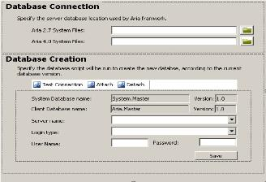

4- Request Handler Service Control (REQUESTHANDLERSERVICECONTROL.CS):
This is user control to handle all setting related request handler (confiner windows services).
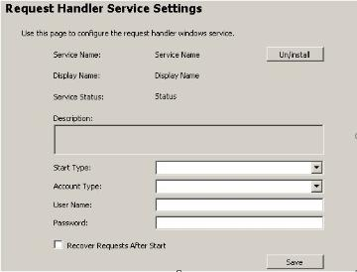

5- Gac Control (GACCONTROL.CS):
This is user control to handle all setting related COM+ (register and Unregister COM+)
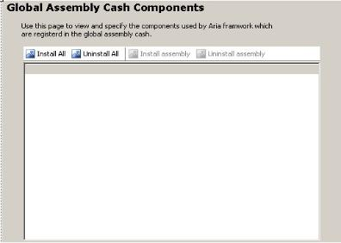

6- Com General Settings Control (COMGENERALSETTINGSCONTROL.CS):
This is User control used to handle general setting of COM+ (COM+ Name, description, activation type<server or Library >… etc)
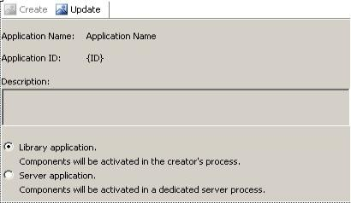

7- Com Control (COMCONTROL.CS):
This is user control used to contain two user controls a- Com General Settings Control
b- Com Components Control 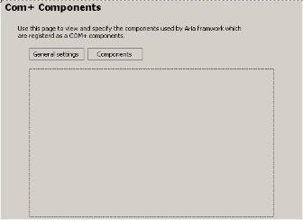

8- Com Components Control (COMCOMPONENTSCONTROL.CS):
This is user control used to set some setting of COM+ as pool size.
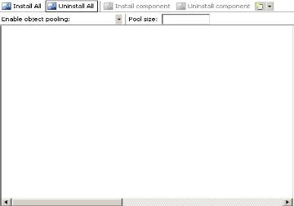

2- Aria Data (ARIA.DATA):
Purpose:
This project used to work with database "FoxPro and SQL Server"(create database connection, retrieve, add, update, delete any data).
Contents:
1- Aria Data Provider (ARIADATAPROVIDER.CS):
This class used to work as SQL statement (insert, update, and select any data in database).
2- Aria Db Command (ARIADBCOMMAND.CS):
Used to execute the SQL statement used some information as connection and database type.
3- Aria Db Connection (ARIADBCONNECTION.CS):
Contain some property help in generate connection string (not responsible of generated any connection string).
4- Aria Db Parameter (ARIADBPARAMETER.CS):
This class contains properties that handle parameters (name and value).
5- Aria Db Parameter Collection (ARIADBPARAMETERCOLLECTION.CS):
This class is collection type where used to save list of parameters and retrieve this parameter depend on index and enable from retrieve count of parameters.
6- Interoperability (INTEROPERABILITY.CS): this class is empty.

3- Aria Data Business Object (ARIA.DATA.BUSINESSOBJECT):
Purpose:
Used to get information about Business object (property related object name).
Contents:
Aria Business Object Adapter (ARIABUSINESSOBJECTADAPTER.CS):
Contain some method used to retrieve some information about object store in System.Master database.

4- Aria Data DataTypes (ARIA.DATA.DATATYPES):
Purpose:
This project service Aria.Utilities.ParameterSubstitution project.
Contents:
1- AriaDataObjectPointerAdapter.cs
2- AriaDataTypeAdapter.cs
3- AriaOptionGridXmlDataSetAdapter.cs

5- Aria DataTypes (ARIA.DATATYPES):
Purpose:
This project create some of properties can use in this system.

6- Aria DataTypes Messaging (ARIA.DATATYPES.MESSAGING):
Purpose:
This project build all property can use in Aria.EnterpriseServices.Messaging project (send Email or create Email Template).
Contents:
1- Aria Email (ARIAEMAIL.CS):
a- create properties can used in send email.
c- Validated message before send.

2- Aria Message Template (ARIAMESSAGETEMPLATE.CS):
Create properties can be used in Email Template.
3- Interoperability (INTEROPERABILITY.CS): this class is empty.

7-Aria DataTypes Object Dictionary (ARIA.DATATYPES.OBJECTDICTIONARY):
Purpose:
Build all properties represent tables in System.Master Database and other properties.where this properties used in Aria.EnterpriseServices.ObjectDictionary
Contents:
1- Aria Argument (ARIAARGUMENT.CS)
2- Aria Argument List (ARIAARGUMENTLIST.CS)
3- Aria Argument Parameterized Value (ARIAARGUMENTPARAMETERIZEDVALUE.CS)
4- Aria Object (ARIAOBJECT.CS)
5- Aria Object Descriptor (ARIAOBJECTDESCRIPTOR.CS)
6- Aria Object Event (ARIAOBJECTEVENT.CS)
7- Aria Object Event Parameter (ARIAOBJECTEVENTPARAMETER.CS)
8- Aria Object Method (ARIAOBJECTMETHOD.CS)
9- Aria Object Method Parameter (ARIAOBJECTMETHODPARAMETER.CS)
10- Aria Object Property (ARIAOBJECTPROPERTY.CS)
11- Aria Object Revision (ARIAOBJECTREVISION.CS)

8- Aria DataTypes Request Handler (ARIA.DATATYPES.REQUESTHANDLER):
Purpose:
Build all properties can use in Aria.EnterpriseServices.RequestHandler project
Contents:
1- Aria Request (ARIAREQUEST.CS)
2- Aria Request Context (ARIAREQUESTCONTEXT.CS)
3- Aria Request Progress (ARIAREQUESTPROGRESS.CS)

9- Aria Enterprise Services Messaging (ARIA.ENTERPRISESERVICES.MESSAGING):
Purpose: sending email and load template from database.
Contents:
1- Aria Messaging DB Centric Template (ARIAMESSAGINGDBCENTRIC.TEMPLATE.CS):
This class used to load template from database where store in Aria.Master database.
2- Aria Messaging Manager (ARIAMESSAGINGMANAGER.CS):
This class used to send email by varies parameter and varies type.

10- Aria Enterprise Services Object Dictionary (ARIA.ENTERPRISESERVICES.OBJECTDICTIONARY):
Purpose:
This project used to handle and mange working with object dictionary.
Contents:
1- Aria Object Dictionary DB Centric (ARIAOBJECTDICTIONARYDBCENTRIC.CS):
Used to work with SYSTEM.MASTER database where can get all objects, get objects depend on object type, get sub objects under object name …etc
2- Aria Object Data Paths Explorer (ARIAOBJECTDATAPATHSEXPLORER.CS):
Used to get all data paths as Email Paths and data paths

11- Aria Enterprise Services Request Handler (ARIA.ENTERPRISESERVICES.REQUESTHANDLER):
Purpose:
Control in request handler services
Contents:
1- Aria Request Agent (ARIAREQUESTAGENT.CS):
This class responsible on run request depends on condition (Execute Immediate Request, Execute One Time Only Requests... etc)
2- Aria Request Scheduler (ARIAREQUESTSCHEDULER.CS):
This class responsible on run request depend on Schedule (this Schedule may be every day or once per days or week per days).
3- Aria Thread Manager (ARIATHREADMANAGER.CS):
This class responsible on run request depends on Threading (Multi-Threading is the ability of a CPU to execute several threads of execution apparently at the same time).

12- Aria Enterprise Services Request Handler Proxy (ARIA.ENTERPRISESERVICES.REQUESTHANDLER.PROXY):
Purpose:
Control all requests (remove, add cancel, load request).
Contents:
1- Aria Request Proxy (ARIAREQUESTPROXY.CS):
This class contains some method to handle request from load, cancel, add, remove and execute.

13- Aria Environment (ARIA.ENVIRONMENT):
Purpose:
Load all information related configuration setting from XML file
Contents:
1- Aria Enviroment Variables (ARIAENVIROMENTVARIABLES.CS):
Load all information related configuration setting from XML file where this information related to database name and username and password, FoxPro paths, services name …. Etc.

14- Aria Object Dictionary UI (ARIA.OBJECTDICTIONARY.UI):
Purpose:
Is user interface project used to browse object dictionary.
Contents:
1- Object Dictionary Viewer (OBJECTDICTIONARYVIEWER.CS):
That is windows form used to browse object dictionary (object store in System.Master Database).
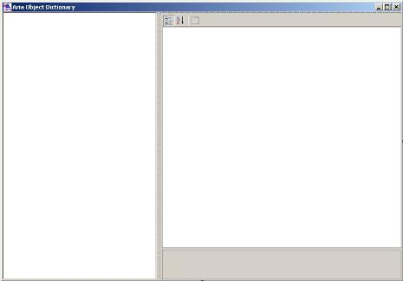

15- Aria Reflection (ARIA.REFLECTION):
Purpose:
Used to Reflection process (Reflection is useful anytime you need to examine or run code that isn’t available at runtime, such as when you need to load add-ons).
Contents:
1- Aria Reflector (ARIAREFLECTOR.CS):
Used to Execute Method, get object, get type of object.

16- Aria Services Request Handler (ARIA.SERVICES.REQUESTHANDLER):
Purpose:
This is windows services project where is responsible on check requests status and run this requests (this services run every period time to check any request must be force).
Contents:
1- Aria Request Handler (ARIAREQUESTHANDLER.CS).
2- Aria Request Handler Installer (ARIAREQUESTHANDLERINSTALLER.CS).

17- Aria Utilities Object Dictionary (ARIA.UTILITIES.OBJECTDICTIONARY):
Purpose:
This is interface project used to manage and work with data dictionary from add or remove new object.
Contents:
1- Object Dictionary (OBJECTDICTIONARY.CS):
This is main windows to manage work with data dictionary.
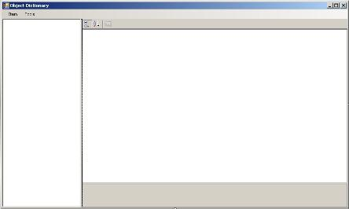

By this screen can
1- Add new object, revision, property, method, method parameter, event and event parameter.
2- Open object.
3- Save object.
4- Delete object.
5- Import table fields.
6- Import table related fields.
7- Import program.
8- Import Report.
Note: found other windows form not list because is sub of previous windows form where is menu item.

18- Aria Utilities Object Dictionary Builder (ARIA.UTILITIES.OBJECTDICTIONARYBUILDER):
Purpose:
This is user interface used to build Object dictionary from scratch (where convert data from aria27 data dictionary to System Master Database).
Contents:
1- Aria Object Dictionary Builder (ARIAOBJECTDICTIONARYBUILDER.CS):
This class contains all information that used to generate Object dictionary.
2- Aria27 Object Dictionary Converter (ARIA27OBJECTDICTIONARYCONVERTER):
This folder contain few classes that build properties can used by AriaObjectDictionaryBuilder.cs
3- Aria Object Dictionary Builder UI (ARIAOBJECTDICTIONARYBUILDERUI.CS):
This is windows form to enable used from build Object dictionary.
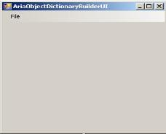

19- Aria Utilities Parameter Substitution (ARIA.UTILITIES.PARAMETERSUBSTITUTION):
Purpose:
Used to substituted parameter
Contents:
1- Aria Parameter Substitute (ARIAPARAMETERSUBSTITUTER.CS):
Contain some method to substituted parameter.

20- Aria Xml (ARIA.XML):
Purpose:
Used to serialize (convert any object to XML to enable from save in database (System.Master)).
Contents:
1- Aria Serializable Attribute (ARIASERIALIZABLEATTRIBUTE.CS): empty.
2- Aria Xml Serializer (ARIAXMLSERIALIZER.CS):
This is class responsible on serializing any object.
3- I Aria Serializable (IARIASERIALIZABLE.CS): is interface.

21- Aria Setups Configuration Server (ARIA.SETUPS.CONFIGURATION.SERVER):
Purpose:
This is setup project used to package Aria.Configuration.Server.

22- Aria Setups Services Request Hanlder (ARIA.SETUPS.SERVICES.REQUESTHANLDER):
Purpose:
This is setup project used to package Aria.Services.RequestHandler.

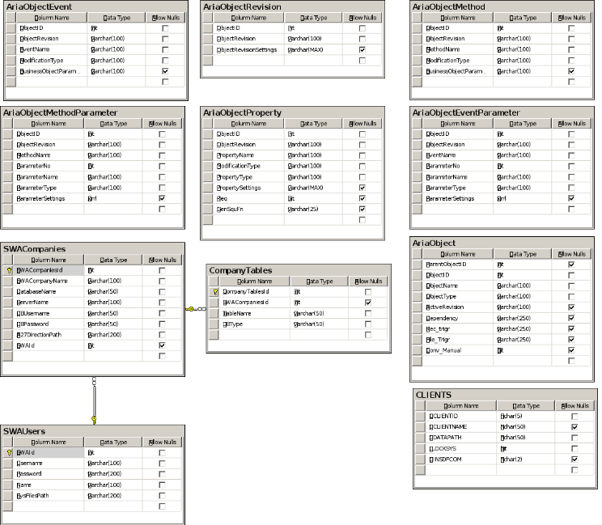
System.Master ERD
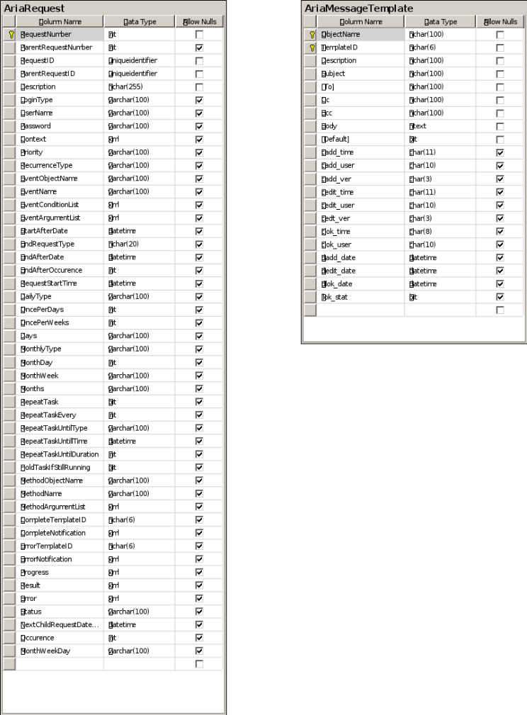
Aria.Master ERD

